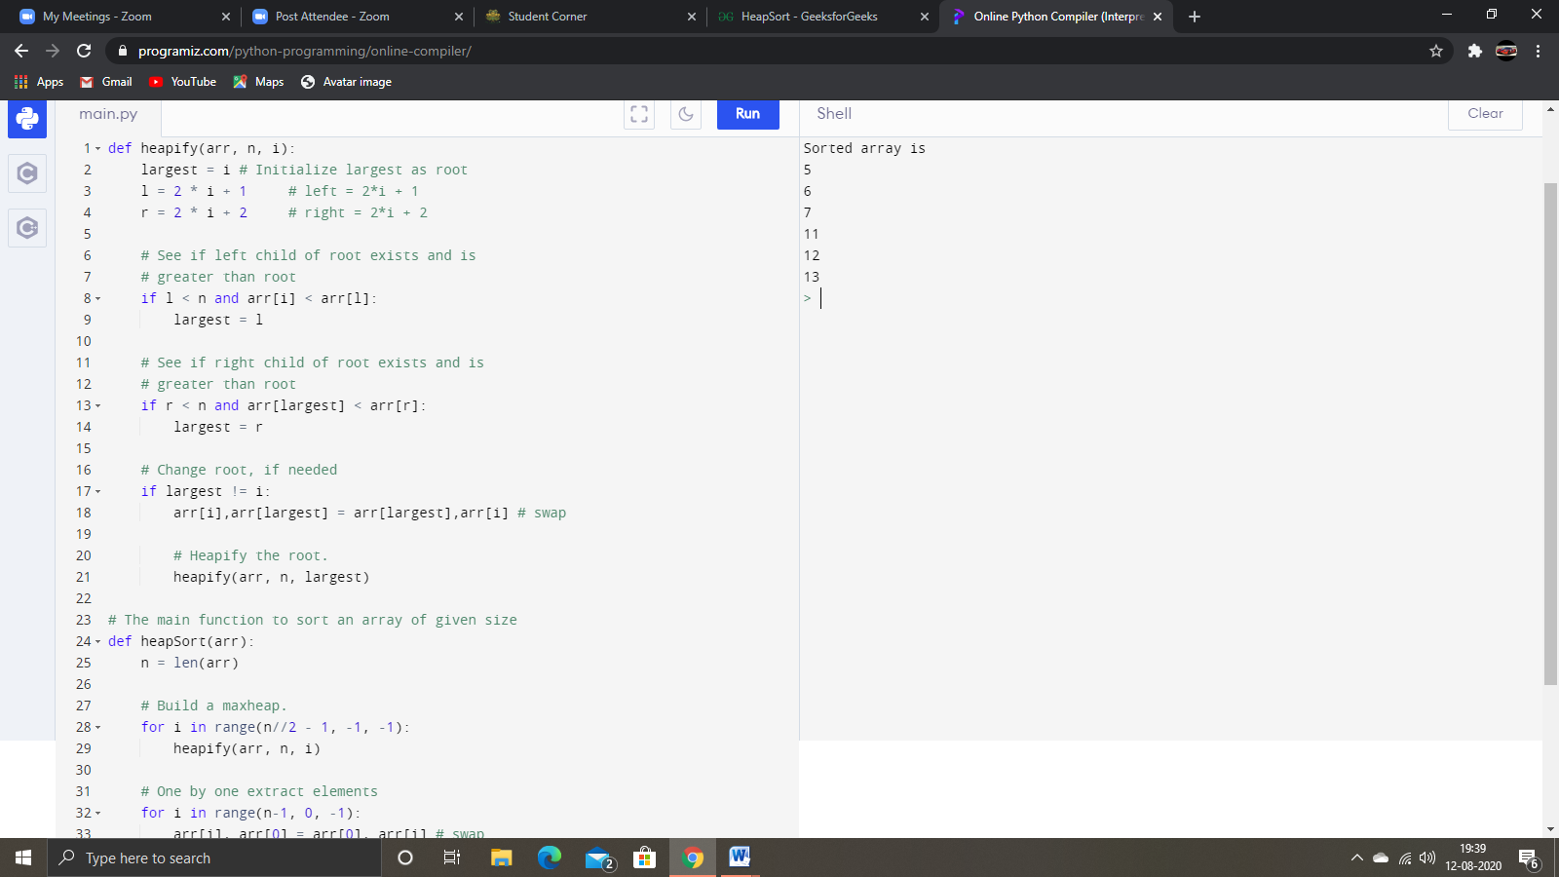**Heap Sort Algorithm for sorting in increasing order:**  
**1.** Build a max heap from the input data.  
**2.** At this point, the largest item is stored at the root of the heap. Replace it with the last item of the heap followed by reducing the size of heap by 1. Finally, heapify the root of tree.  
**3.** Repeat above steps while size of heap is greater than 1.

**>>**Time complexity of heap sort is O(Logn). Time complexity of createAndBuildHeap() is O(n) and overall time complexity of Heap Sort is O(nLogn).

